**MINI PROJECT**

**TOPIC :** SNAKE GAME PROJECT

**OBJECTIVE:**

**To construct a program to play the snake game**

**DESCRIPTION:**

1.The snake is represented with a **0**(zero) symbol.

2.The fruit is represented with an **\***(asterisk) symbol.

3.The snake can move in any direction according to the user with the help of the keyboard (**W**, **A**, **S**, **D** keys).

4.When the snake eats a fruit the score will increase by 10 points.

5.The fruit will generate automatically within the boundaries.

6.Whenever the snake will touch the boundary the game is over.

**The user defined functions used :**

**Draw(): This function creates the boundary in which the game will be played.**

**Setup(): This function will set the position of the fruit within the boundary.**

**Input(): This function will take the input from the keyboard.**

**Logic(): This function will set the movement of the snake**.

**The built in functions used:**

**kbhit(): This function in**[**C**](https://www.geeksforgeeks.org/c-programming-language/)**is used to determine if a key has been pressed or not. To use this function in a program include the header file [conio.h](https://www.geeksforgeeks.org/getch-function-in-c-with-examples/). If a key has been pressed, then it returns a non-zero value otherwise it returns zero.**

**rand(): The**[**rand()**](https://www.geeksforgeeks.org/rand-and-srand-in-ccpp/)**function is declared in [stdlib.h](https://www.geeksforgeeks.org/whats-difference-between-and/). It returns a random integer value every time it is called.**

**CODING:**

**#include <conio.h>**

**#include <stdio.h>**

**#include <stdlib.h>**

**#include <unistd.h>**

**int i, j, height = 20, width = 20;**

**int gameover, score;**

**int x, y, fruitx, fruity, flag;**

**void setup()**

**{**

**gameover = 0;**

**// Stores height and width**

**x = height / 2;**

**y = width / 2;**

**label1:**

**fruitx = rand() % 20;**

**if (fruitx == 0)**

**goto label1;**

**label2:**

**fruity = rand() % 20;**

**if (fruity == 0)**

**goto label2;**

**score = 0;**

**}**

**// Function to draw the boundaries**

**void draw()**

**{**

**system("cls");**

**for (i = 0; i < height; i++) {**

**for (j = 0; j < width; j++) {**

**if (i == 0 || i == width - 1**

**|| j == 0**

**|| j == height - 1) {**

**printf("#");**

**}**

**else {**

**if (i == x && j == y)**

**printf("0");**

**else if (i == fruitx**

**&& j == fruity)**

**printf("*");**

**else**

**printf(" ");**

**}**

**}**

**printf("\n");**

**}**

**// Print the score after the**

**// game ends**

**printf("score = %d", score);**

**printf("\n");**

**printf("press X to quit the game");**

**}**

**// Function to take the input**

**void input()**

**{**

**if (kbhit()) {**

**switch (getch()) {**

**case 'a':**

**flag = 1;**

**break;**

**case 's':**

**flag = 2;**

**break;**

**case 'd':**

**flag = 3;**

**break;**

**case 'w':**

**flag = 4;**

**break;**

**case 'x':**

**gameover = 1;**

**break;**

**}**

**}**

**}**

**// Function for the logic behind**

**// each movement**

**void logic()**

**{**

**sleep(0.01);**

**switch (flag) {**

**case 1:**

**y--;**

**break;**

**case 2:**

**x++;**

**break;**

**case 3:**

**y++;**

**break;**

**case 4:**

**x--;**

**break;**

**default:**

**break;**

**}**

**// If the game is over**

**if (x < 0 || x > height**

**|| y < 0 || y > width)**

**gameover = 1;**

**// If snake reaches the fruit**

**// then update the score**

**if (x == fruitx && y == fruity) {**

**label3:**

**fruitx = rand() % 20;**

**if (fruitx == 0)**

**goto label3;**

**// After eating the above fruit**

**// generate new fruit**

**label4:**

**fruity = rand() % 20;**

**if (fruity == 0)**

**goto label4;**

**score += 10;**

**}**

**}**

**// Driver Code**

**void main()**

**{**

**int m, n;**

**// Generate boundary**

**setup();**

**// Until the game is over**

**while (!gameover) {**

**// Function Call**

**draw();**

**input();**

**logic();**

**}**

**}**

**OUTPUT:**

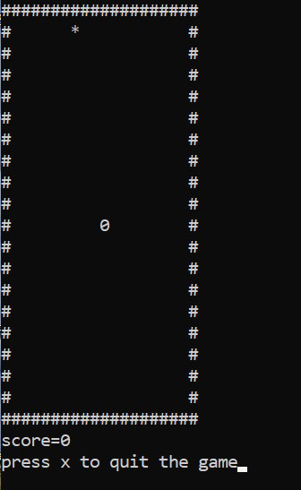

**DONE BY:**

ARAVIND IL (RA2111042010014)

KISHOREKUMAR K (RA2111042010024)